|  |  |
| --- | --- |
| NAME OF INTERN | Marcus Yeo YaoHeng |
| NAME OF DSO SUPERVISOR | Koh Hang Kiat, Simon |
| DATE OF INTERNSHIP | 08/05/2023 – 28/07/2023 |

1. Overview of your internship assignment (Main focus of your report)

During my internship, I undertook the exciting project of creating an Intelligent Chatbot Assistant for the ES Division as part of a larger application. The goal was to provide a user-friendly solution for handling queries and deriving insights from an analytical tool backed by a database, without the need for complex UI/UX processes.

As part of the requirements of the chatbot, it has to be able to hold basic conversations with users, as well as perform data retrieval via querying a local SQLite database and perform summarization tasks (flow illustrated below). A proxy use case would be that of a superstore app that has customer and staff modes. A customer might be interested in finding out all the unique brands available, the prices of certain products, or what products are in stock by a particular brand. Customers would then be able to use this chatbot to make their queries as if they were using a search engine, and the Chatbot would be able to take in the query, parse and rationalize it through the NLU component and query the SQLite database if necessary, returning the desired result. On the other hand, the staff mode would have functions unavailable to the customer, such as the ability to see transaction data or confidential information. This provides a wide range of functionalities to different groups of users who might want to access the same data.

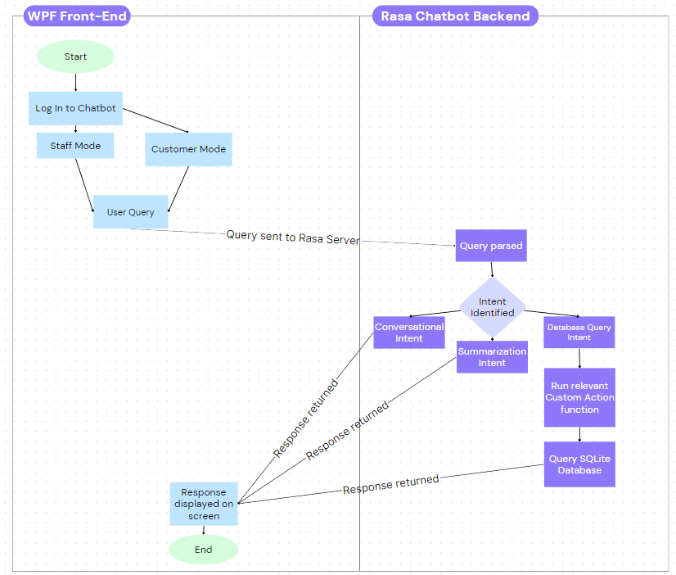

Flowchart representing how a query is processed by the Rasa Chatbot

To begin my project, I conducted extensive research on various chatbot frameworks and engines. This involved delving into the underlying principles of chatbots and understanding how Natural Language Processing (NLP) is applied. Considering the project requirements, such as the need for an offline chatbot capable of querying a SQLite database and performing keyword and semantic searches, I carefully evaluated different open-market frameworks like GPT-3, Botpress, ChatterBot, and Rasa. After thorough consideration, I decided to utilize the Rasa framework. Having previous experience with Rasa and recognizing its versatility and powerful NLU component, it emerged as the ideal choice for this project.

With the framework selected, I dove into the Rasa documentation, which proved vital in comprehending the inner workings of the chatbot and designing the software architecture. I meticulously crafted numerous use-cases, known as "stories", and user inputs, referred to as "intents." This planning stage was critical as these would serve as training data, enhancing the accuracy of intent classification within the NLU component. Additionally, I carefully devised conversation flows and planned the chatbot's responses, or "utters," to ensure a smooth implementation in later stages.

Once I had developed an extensive set of intentions, stories, and utters, I proceeded to build the prototype chatbot. While there was already a template in place, I encountered some challenges during the implementation of custom actions, which involved the integration of SQL queries to interface with the database and retrieve relevant user query results. Through persistence and multiple attempts, I successfully connected to the local database, enabling the chatbot to accept user inputs and provide results on the terminal.

The next hurdle was integrating Rasa with a WPF C# front-end to offer a more user-friendly interface. I overcame this challenge by tinkering with the REST API of Rasa, allowing for seamless connection with the chatbot once a local server was set up. However, there were complexities in parsing the output from Rasa and converting the returned JSON string, containing the table schema, into a presentable table to be displayed on the WPF App. This was eventually overcome through multiple revisions of how data was returned by Rasa and how it was interpreted by the WPF App.

Looking ahead, I plan to advance the project by further refining the WPF App and continuously expanding the chatbot's use-case repertoire. Regular updates to the chatbot's corpus will be essential for enhancing its performance. Additionally, I aim to enhance the user interface to make it more visually appealing and intuitive. Furthermore, I intend to incorporate quality-of-life (QOL) features to maximize user convenience.

1. How the project / research can be applied to DSO/Division’s mission and vision

**DSO Mission:** To develop technologies and solutions that can provide technological surprises to sharpen the cutting edge of Singapore's national security.

**DSO Vision:** To be a wellspring of technological knowledge, a fountain of innovation and an inspiration to the R&D community in Singapore.

**ES Div Mission:** The Electronic Systems Division advances electronic warfare systems with radio frequency and micro-electronics technologies and provides electromagnetic superiority.

In my opinion, my project has several applications that align with the mission and vision of DSO and the ES Division. Although the project does not directly contribute to the ES vision, it definitely supports it through enhancing the user analysis tool by streamlining information retrieval and analysis processes. Operators and analysts can utilize the chatbot to quickly retrieve critical data, obtain summarized insights, and make informed decisions in the context of electronic warfare operations. This contributes to the division's objective of achieving technological excellence in electronic warfare systems and maintaining electromagnetic superiority.

Besides serving the main objective, this project can also be applied to DSO’s vision and mission. The Chatbot Assistant can serve as a repository of technological knowledge within DSO and the ES Division. It can accumulate and retain a vast amount of information, including project details, inventory status, and reports. This knowledge base can be accessed by all members of the organization, with restrictions put in place for different security clearances, making it a secure and valuable resource for decision-making and problem-solving within DSO.

By providing quick and accurate information retrieval and summarization capabilities, the Chatbot Assistant streamlines tasks and improves efficiency for both customers and staff members. This contributes to DSO's mission to provide technological solutions that enhance productivity and effectiveness.

1. Challenges faced during your internship

During my internship, I encountered several challenges that tested my skills and required problem-solving. Here are the key challenges I faced:

1. Lack of experience with Rasa and NLP/NLU: One of the major challenges was my limited experience with Rasa and the concepts of NLP and NLU. As the project involved building a chatbot from scratch, I had to invest significant time and effort in self-learning. Through thorough research, studying the Rasa documentation, and watching tutorials, I quickly gained the necessary knowledge and skills to work effectively with Rasa and understand its functionalities.
2. Connecting Rasa to the WPF App: Integrating Rasa with the WPF App posed a challenge due to limited online resources for the specific version I was working with. The lack of information on connecting external clients to the Rasa API made it difficult to establish a connection. I had to experiment, perform trial and error, and extensively study the endpoint.yml file to successfully connect the WPF App to Rasa's API.
3. Displaying results as a table in the WPF App: Presenting the results returned by Rasa in a table format within the WPF App proved to be another challenge. My limited experience with Rasa and unfamiliarity with the specific format of the API responses led to errors when parsing the data. This became particularly problematic when querying custom actions and wanting to display the results as a table. After multiple attempts and making adjustments to the data format returned by Rasa, I managed to overcome the challenges and successfully display the information in the desired table form, ensuring a seamless connection between the front-end and back-end.

These challenges allowed me to gain valuable experience and enhance my problem-solving abilities. By immersing myself in self-learning, conducting thorough research, and persistently experimenting, I was able to overcome these obstacles.

1. Lessons learnt from the tasks assigned to you

From the tasks assigned to me during my internship, I gained valuable lessons that have had a lasting impact on my professional growth. Here are some of the key lessons I learned:

1. The significance of conducting a thorough literature review and research: Before starting my internship, I had a preconceived notion about using the ChatterBot framework based on a recommendation from a friend. However, as part of the project requirements, I was required to conduct extensive research on various chatbot frameworks. This process opened my eyes to the disadvantages of ChatterBot, such as its limited modularity and steep learning curve. It also introduced me to the advantages of the Rasa framework, which ultimately proved to be the optimal choice for the project. This experience emphasized the importance of conducting a comprehensive literature review and research before diving into a project. It taught me the value of exploring multiple options and understanding their pros and cons, enabling me to make informed decisions that can bring greater benefits in the long run.
2. The power of self-learning and resourcefulness: Throughout the internship, I encountered challenges that required me to learn new skills and technologies independently. From understanding the fundamentals of NLP and NLU to integrating Rasa with the WPF App, I had to rely on self-learning resources, such as the Rasa documentation and online tutorials. This experience taught me the importance of being resourceful, proactive, and self-motivated in acquiring new knowledge and skills. It highlighted the significance of continuously seeking out learning opportunities, even in unfamiliar domains, to overcome challenges and deliver successful outcomes.

Overall, the tasks assigned to me during my internship provided valuable lessons that have shaped my approach to future projects. I now recognize the significance of conducting thorough research, being resourceful in acquiring new skills, and maintaining persistence and problem-solving abilities. These lessons have not only enhanced my technical capabilities but have also fostered a mindset of continuous learning and adaptability in the face of challenges.

1. Positive experiences in DSO

During my time at DSO, I have had several positive experiences that have contributed to a pleasant and welcoming environment. Despite the remote nature of my work, I have had the opportunity to connect with other interns in the same department. Interacting with them has allowed me to settle in more easily. Having familiar faces around has provided a support system, and we often check in with each other on our progress and share experiences. These connections have made the work environment more enjoyable and collaborative.

From the very beginning, DSO has made an effort to ensure that interns feel welcome and supported. The first-day welcoming activities and gestures have been a nice touch, helping to create a positive first impression. Moreover, the staff at DSO has been understanding and accommodating, always ready to assist and provide guidance. Their open and helpful nature has made it easier for me to navigate through any challenges I faced, and I appreciate their willingness to lend a hand.

In summary, my experiences at DSO have been predominantly positive. The opportunity to connect with colleagues, the welcoming and supportive environment, and the overall care shown towards interns have all contributed to a pleasant work experience. These positive aspects have made my time at DSO enjoyable, despite the remote work arrangements, and have allowed me to settle in smoothly and feel supported throughout my internship.

1. Areas to improve

In my opinion, there are some areas that can be improved such as the laptops provided to the interns. The laptop I was issued is a Thinkpad which although worked fine, was very slow when connecting to the internet or doing simple tasks like refreshing emails. The biggest issue with the computer was when downloading applications, which due to the security software installed, caused download times to increase drastically, resulting in many wasted hours of waiting for software to be installed.

Another area that could potentially be improved would be the places that the interns were given to work. While there was an intern room provided, there were simply too many interns and some including myself were allocated to work in a conference room with 8 other interns. Although I mainly worked from home, the conference room was small and had no separate desks, making it a very unconducive place to work.

1. Changes that you would recommend

Some changes that I would recommend would be to provide faster laptops with a larger screen. For interns doing coding projects, ideally a keyboard and a monitor could be issued to them to better allow them to complete their work.

Interns could also be issued their own desk and locker instead of being allocated into a meeting room, which would go a long way to helping them settle down and providing them a conducive environment to work.

1. Whether your initial expectations have been met

My initial expectations have definitely been met. When I first joined, I had high expectations regarding the learning opportunities available at DSO, particularly in the field of emerging technologies and national security. I am pleased to say that my internship has provided ample opportunities for learning and skill development. From working on the chatbot project to exploring different frameworks and technologies, I have gained valuable knowledge and practical experience. The exposure to real-world challenges and the guidance provided by mentors and colleagues have significantly contributed to my professional growth.

1. Thoughts about your internship supervisor

I am extremely grateful for the exceptional organizational skills and support provided by my internship supervisor, Simon, during my time at DSO. His meticulous planning, clear instructions, and the provision of a project timeline made it seamless for me to integrate and hit the ground running in a new working environment. Simon's ability to provide clear instructions and articulate project expectations has been invaluable. From the start, he ensured that I had a comprehensive understanding of the project scope, goals, and desired outcomes. He took the time to explain complex concepts, discuss project requirements, and provide detailed guidelines to facilitate my progress. Additionally, Simon's effective project planning, including the creation of a timeline, enabled me to have a clear roadmap for my tasks and milestones. This level of organization made it easy for me to prioritize and manage my work efficiently.

Alongside his organizational skills, Simon has consistently provided supportive guidance throughout the internship. He has been available to address any questions or concerns I had, offering valuable insights and suggestions to enhance my work, always answering my questions quickly. Simon's approachability and willingness to provide assistance have created a collaborative atmosphere where I felt comfortable seeking advice and feedback. This supportive guidance has not only helped me overcome challenges but has also fostered my professional growth and development.

Overall, Simon's exceptional organizational skills, clear instructions, and project planning have played a pivotal role in my internship experience. His efforts to provide a well-structured framework, seamless integration, and supportive guidance have contributed to a positive and productive working environment. I am truly grateful for his commitment to ensuring my success and making my internship journey at DSO a fulfilling and rewarding one.

1. Thoughts on your future career

My internship experience at DSO has had a profound impact on my future career aspirations. The exposure to working on the chatbot project and gaining hands-on experience in software engineering has boosted my confidence as a professional in this field. Through the challenging tasks and responsibilities assigned to me during my internship, I have grown significantly in terms of technical skills and problem-solving abilities. The guidance and support provided by my colleagues and supervisor have helped me overcome obstacles and achieve project milestones. As a result, I feel more confident in my capabilities as a software engineer, equipped with practical knowledge and experience gained from working on real-world projects. This increased confidence will undoubtedly benefit my future career endeavors.

The exposure to NLP and NLU during my internship has sparked a keen interest in this field. Working on the chatbot project, exploring different frameworks, and understanding the principles behind NLP have given me a glimpse into the fascinating world of language-based technology. The potential to develop intelligent systems that can understand and interact with humans in a natural and meaningful way has captivated my curiosity. As a result, I am now considering the possibility of pursuing NLP and NLU development in my future career.

My internship experience has highlighted the importance of continuous learning and staying updated with emerging technologies. It has also emphasized the significance of gaining expertise in specific areas of interest. Moving forward, I intend to expand my knowledge in NLP and NLU by exploring advanced concepts, pursuing relevant courses or certifications, and participating in research or development projects in this domain. This commitment to ongoing learning and growth will allow me to stay at the forefront of technological advancements and contribute meaningfully to the field.